**Lab 9**

Link for assignment **:** <https://github.com/Diya-Lad/SDP>

**Tutorial 1**

Here we have created special stateless widget called QuoteCard for printing our quotes in special pattern.

Earlier we have done this using widget in _EchoListState class.

Main.dart

import 'package:flutter/material.dart';  
import 'quote.dart';  
import 'quote_card.dart';  
  
void main() {  
 runApp(EchoList());  
}  
  
class EchoList extends StatefulWidget {  
 const EchoList({Key? key}) : super(key: key);  
  
 @override  
 State<EchoList> createState() => _EchoListState();  
}  
  
class _EchoListState extends State<EchoList> {  
 @override  
 List<Quote> quotes = [  
 Quote(text: 'The truth is realy pure and never simple',author: 'author1'),  
 Quote(author: ' author2', text: 'I see humans but no humanity'),  
 Quote(text: 'The time is always right to do what is right',author: ' author3'),  
 ];  
  
  
 Widget quoteTemplate(quote){  
 return QuoteCard(quote: quote,);  
 }  
 @override  
 Widget build(BuildContext context) {  
 return Scaffold(  
 backgroundColor: Colors.*lightBlueAccent*[100],  
 appBar: AppBar(  
 title: Text('Quotes'),  
 centerTitle: true,  
 backgroundColor: Colors.*orangeAccent*,  
 ),  
 body: Column(  
 children: quotes.map((quote) => QuoteCard(quote: quote)).toList(),  
 ),  
 );  
 }  
}

quote_dart.dart

import 'package:flutter/material.dart';  
import 'quote.dart';  
  
class QuoteCard extends StatelessWidget {  
  
 final Quote quote;  
 QuoteCard({required this.quote});  
 @override  
 Widget build(BuildContext context) {  
 return Card(  
 margin: EdgeInsets.fromLTRB(20.0, 30.0, 40.0, 10.0),  
 child: Padding(  
 padding: const EdgeInsets.all(12.0),  
 child: Column(  
 crossAxisAlignment: CrossAxisAlignment.stretch,  
 children: [  
 Text(  
 quote.text,  
 style: TextStyle(  
 fontSize: 20,  
 color: Colors.*deepPurple*,  
 ),  
 ),  
 SizedBox(height: 10),  
 Text(  
 quote.author,  
 style: TextStyle(  
 fontSize: 26,  
 color: Colors.*deepPurple*,  
 ),  
 ),  
 ],  
 ),  
 ),  
 );  
 }  
}

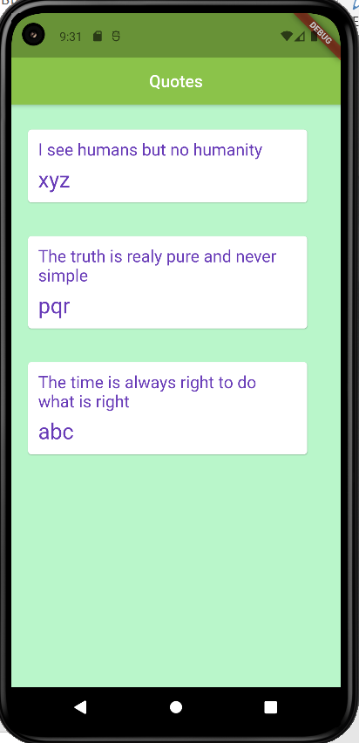

Code test 2: Function as arguments and real use of “Stateful widget” and delete operation

Main.dart

import 'package:flutter/material.dart';  
import 'quote.dart';  
import 'package:lab9/quote_card.dart';  
void main() => runApp(MaterialApp(  
 home: EchoList(),  
));  
  
class EchoList extends StatefulWidget {  
 const EchoList({Key? key}) : super(key: key);  
  
 @override  
 State<EchoList> createState() => _EchoListState();  
}  
  
class _EchoListState extends State<EchoList> {  
 List<Quote> quotes = [  
 Quote(author: 'xyz', text: 'I see humans but no humanity'),  
 Quote(text: 'The truth is realy pure and never simple', author: 'pqr'),  
 Quote(  
 text: 'The time is always right to do what is right',  
 author: 'abc'),  
 ];  
 /*  
 Widget quoteTemplate(quote) {  
 return QuoteCard(quote:quote);  
 }  
 */  
  
 @override  
 Widget build(BuildContext context) {  
 return Scaffold(  
 backgroundColor: Colors.*greenAccent*[100],  
 appBar: AppBar(  
 title: Text('Quotes'),  
 centerTitle: true,  
 backgroundColor: Colors.*lightGreen*,  
 ),  
 body: Column(  
 // children: quotes.map((quote) => quoteTemplate(quote)).toList(),  
 // children: quotes.map((quote) => QuoteCard(quote: quote)).toList(),  
 children: quotes.map((quote) => QuoteCard(  
 quote: quote,  
 delete: () {  
 setState(() {  
 quotes.remove(quote);  
 });  
 },  
 )).toList(),  
 ),  
 );  
 }  
}

quote_card.dart

import 'package:flutter/cupertino.dart';  
import 'package:flutter/material.dart';  
import 'package:lab9/quote.dart';  
class QuoteCard extends StatelessWidget {  
 final Quote quote;  
 final VoidCallback delete;  
 QuoteCard({required this.quote,required this.delete});  
  
  
 @override  
 Widget build(BuildContext context) {  
 return Card(  
 margin: EdgeInsets.fromLTRB(20.0, 30.0, 40.0, 10.0),  
 child: Padding(  
 padding: const EdgeInsets.all(12.0),  
 child: Column(  
 crossAxisAlignment: CrossAxisAlignment.stretch,  
 children: [  
 Text(  
 quote.text,  
 style: TextStyle(  
 fontSize: 20,  
 color: Colors.*deepPurple*,  
 ),  
 ),  
 SizedBox(height: 10),  
 Text(  
 quote.author,  
 style: TextStyle(  
 fontSize: 26,  
 color: Colors.*deepPurple*,  
 ),  
 ),  
 SizedBox(height: 8.0,),  
 TextButton.icon(  
 onPressed: delete,  
 icon: Icon(Icons.*delete*),  
 label: Text('Delete Quote'),  
 ),  
 ],  
 ),  
 ),  
 );  
 }  
}

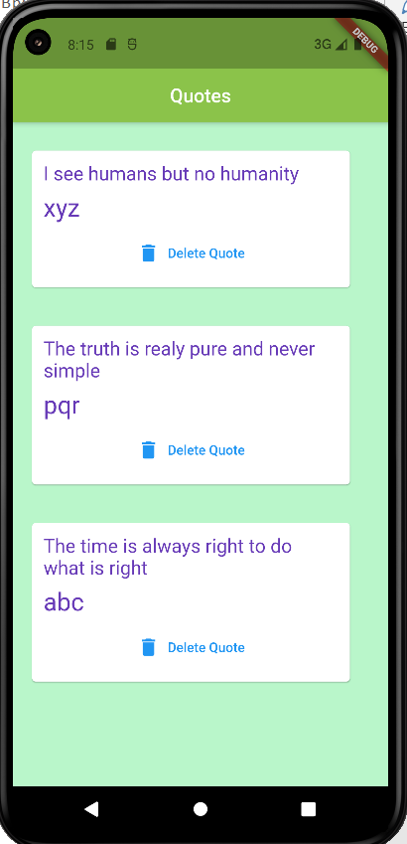

**Tutorial 2**

In home.dart

import 'package:flutter/material.dart';  
class Home extends StatefulWidget {  
 @override  
 State<Home> createState() => _HomeState();  
}  
class _HomeState extends State<Home> {  
 @override  
 Widget build(BuildContext context) {  
 return Scaffold(  
 body: Text('HOME SCREEN'),  
 );  
 }  
}

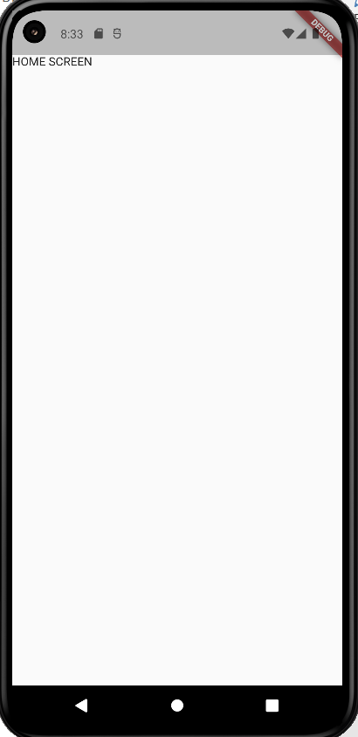

**Route widget**

* The application's top-level routing table.
* When a named route is pushed with Navigator.pushNamed(), the route name is looked up in this map. If the name is present, the associated widgets.WidgetBuilder() is used to construct a MaterialPageRoute that performs an appropriate transition, including Hero animations, to the new route.
* If the app only has one page, then you can specify it using home instead.
* If home is specified, then it implies an entry in this table for the Navigator.defaultRouteName() route (/), and it is an error to redundantly provide such a route in the routes table.
* If a route is requested that is not specified in this table (or by home), then the onGenerateRoute() callback is called to build the page instead.
* The Navigator is only built if routes are provided (either via home, routes, onGenerateRoute, or onUnknownRoute); if they are not, builder must not be null.

**Navigation between the pages:**

Main.dart :

void main() => runApp(MaterialApp(  
 // home: Home(),  
 initialRoute: '/home',  
 routes: {  
 '/': (context) => Loading(),  
 '/home': (context) => Home(),  
 '/location': (context) => ChooseLocation(),  
 }  
));

home.dart :

import 'package:flutter/material.dart';  
class Home extends StatefulWidget {  
 @override  
 State<Home> createState() => _HomeState();  
}  
class _HomeState extends State<Home> {  
 @override  
 Widget build(BuildContext context) {  
 return Scaffold(  
 body: SafeArea(  
 child:Column(  
 children: [  
 TextButton.icon(  
 onPressed: (){  
 Navigator.*pushNamed*(context, '/location');  
 },  
 icon: Icon(Icons.*edit_location*),  
 label:Text('EDIT LOCATION'),  
 )  
 ],  
 )  
 ),  
 );  
 }  
}

choose_location.dart :

import 'package:flutter/material.dart';  
class ChooseLocation extends StatefulWidget {  
// const ChooseLocation({Key? key}) : super(key: key);  
 @override  
 State<ChooseLocation> createState() => _ChooseLocationState();  
}  
class _ChooseLocationState extends State<ChooseLocation> {  
 @override  
 Widget build(BuildContext context) {  
 return Scaffold(  
 backgroundColor: Colors.*cyan*[100],  
 appBar: AppBar(  
 backgroundColor: Colors.*deepPurpleAccent*,  
 title: Text('Choose Location'),  
 centerTitle: true,  
 elevation: 0,  
 ),  
 body: Text('Choose location screen'),  
 );  
 }  
}

* The Navigator class provides all the navigation capabilities in a Flutter app.
* Navigator provides methods to mutate the stack by a push to stack or by popping from the stack. The Navigator.push() method is for navigating to a newer page and Navigator.pop() is for going back from the current page.

